SCHEDULE 1 TO THE DEVELOPMENT CONTRIBUTIONS PLAN OVERLAY

--/--/----

Proposed C115

Shown on the planning scheme map as DCPO1.

BANYULE DEVELOPMENT CONTRIBUTIONS PLAN 2016-17

1.0 Area covered by this development contributions plan

This Development Contributions Plan (DCP) applies to all new development within the 24 Charge Areas as shown below.

--/--/----

Proposed C115

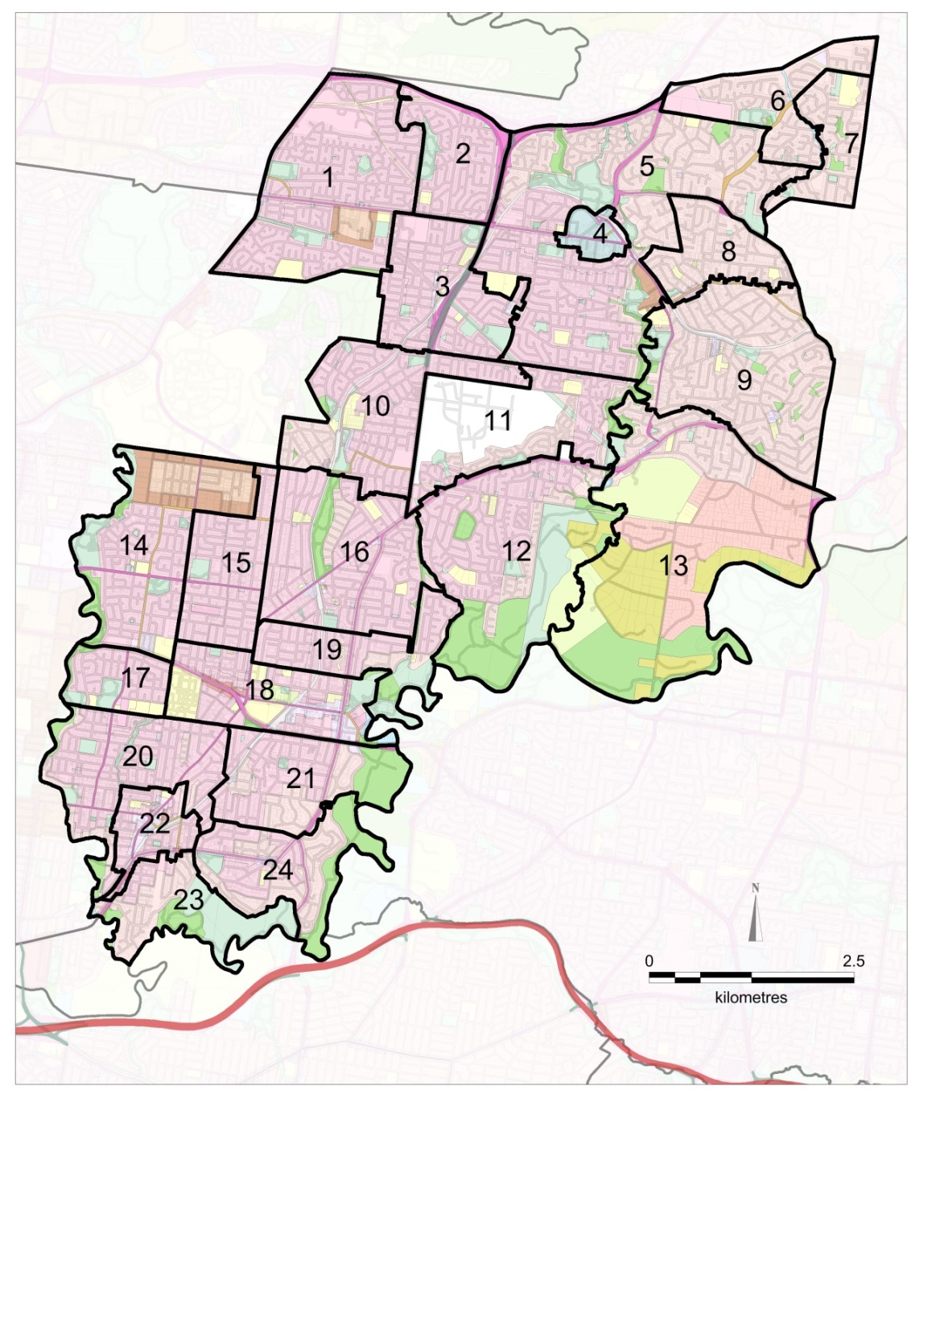

2.0 Summary of costs



--/--/----

Proposed C115

Notes:

This table sets out a summary of the costs prescribed in the Development Contributions Plan. Refer to the reference document (Banyule Development Contribution Plan Area, 2016-17) for full details.

Banyile City Council commits to delivering the DCP projects by December 31 2036, but may deliver projects earlier. It is likely that projects will be progressively delivered over the DCP period.

Banyule City Council is Collection Agency for this DCP and all its projects.

Banyule City Council is Development Agency for this DCP and all its projects, apart from Project Number 1, for which La Trobe University is Development Agency. Refer to the Incorporated Document for details.

Should Council not proceed with any of the infrastructure projects listed in this DCP, the funds collected for these items will be either:

* Used for the provision of other infrastructure as approved by the Minister responsible for the Planning and Environment Act, or
* Refunded to owners of land subject to these DCP charges.

3.0 Summary of contributions



--/--/----

Proposed C115







Notes:

Square metres of floorspace (SQM) refers to gross floorspace.

The above listed contribution amounts are current as at 30 June 2017. They will be adjusted annually on July 1 each year to cover inflation, by applying the Consumer Price Index for Melbourne (All Groups) as published by the Australian Bureau of Statistics. A list showing the current contribution amounts will be held at Council’s Planning Department.

For land uses not included within the Planning Scheme definition of the above uses, the development contribution that applies to ‘Commercial’ will be used unless the Collection Agency agrees to vary that rate based on a submission by a permit applicant that can, to the satisfaction of the Collection Agency, justify the application of an alternative rate.

Payment of development contributions is to be made in cash.

Council may accept the provision of land, works, services or facilities by the applicant in part or full satisfaction of the amount of levy payable.

Each net additional demand unit shall be liable to pay the DCP levy (unless exemptions apply). This includes a new dwelling or building or an extension to an existing non-residential building.

Minor changes to pre-existing non-residential development of less than 50 sqm net change shall be exempt from the DCP levy.

Payment of the Development Infrastructure Levy can be made at subdivision stage, planning permit stage or building permit stage.

* Development Infrastructure Levy at Subdivision Stage - Payment of the Development Infrastructure Levy is to be made prior to the issue of a statement of compliance for the approved subdivision.
* Development Infrastructure Levy at Planning Permit Stage - Payment of the Development Infrastructure Levy is to be made prior to the commencement of any development or works.
* Development Infrastructure Levy at Building Permit Stage - Payment of the Development Infrastructure Levy is to be made no later than the date of issue of a building permit under the Building Act 1993.

Payment of the Community Infrastructure Levy must be made at the building permit stage.

* Community Infrastructure Levy at Building Permit Stage - Payment of the Community Infrastructure Levy is to be made no later than the date of issue of a building permit under the Building Act 1993.

The Collection Agency may, at its discretion, agree for payment of a levy to be deferred to a later date, subject to the applicant entering into an agreement under section 173 of the Planning and Environment Act 1987 to pay the levy at an alternative date.

4.0 Land or development excluded from development contributions plan

No land or development is exempt from this Development Contributions Plan unless exempt by Legislation or Ministerial Direction or Legal Agreement with Banyule City Council or stated below.

--/--/----

Proposed C115

The following development is exempt from a development contribution:

* Land developed for a non-government school, as defined in Ministerial Direction on the Preparation and Content of Development Contributions Plans of 11 October 2016;
* Land developed for housing by or for the Department of Health and Human Services, as defined in Ministerial Direction on the Preparation and Content of Development Contributions Plans of 11 October 2016. This applies to social housing development delivered by and for registered housing associations. This exemption does not apply to private dwellings developed by the Department of Health and Human Services or registered housing associations;
* Cohousing development that meets a minimum threshold as defined by the Responsible Authority as shown in Appendix 5;
* Renovations or alterations to an existing building that do not generate a net increase in demand units;
* Dwelling units that are replaced within a development are exempt. This exemption does not apply to net additional dwelling units created by the development;
* Minor changes to pre-existing non-residential development of less than 50 sqm net change shall be exempt from the DCP levy; and
* Land which has an existing section 173 Agreement under the Planning and Environment Act 1987 and/or a Deed of Agreement which requires the payment of a contributions levy and/or construction of community and/or physical infrastructure.