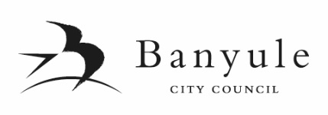

SUBMISSION FORM
PROPOSED BUDGET 2020/2021 and COUNCIL PLAN 2017-2021(YEAR 4)

I wish to make a submission to Banyule City Council regarding the proposed Budget and/or Council Plan presented to the Council meeting held on Monday 4 May 2020. My submission is in relation to:

Proposed Budget 2020/2021 and/or Proposed Council Plan 2017-2021(Year 4)

Comment: (please use block letters when completing this form)

I am making a submission as:

an individual a representative of an organisation or community group

I,
 | (Given Name) | (Surname)
of
 | (Address)
 | Organisation (if applicable)
Phone:
Email:
(if you provide your email address it will be assumed you agree to receive correspondence via email)

Do you wish to speak to this submission at the Special Council Meeting on Wednesday 17 June 2020?

Yes No (Note: only those that indicate their desire to speak will be given the opportunity to speak to their submission.)

Submissions Close | 5pm on Thursday 4 June 2020
Hearing of Submissions | Special Council Meeting - 7pm on Wednesday 17 June 2020
Submissions Considered | Council Meeting – 7pm on Monday 6 July 2020

Submissions need to be clearly marked ‘Council Plan Submission’ or ‘Budget Submission’.
Please send to: Banyule City Council, PO Box 94, GREENSBOROUGH VIC 3088
or email to: enquiries@banyule.vic.gov.au
Signed: Dated:
I understand that the information provided above will be used in accordance with relevant legislation and declare that this information is correct to the best of my knowledge.
Please see Privacy Collection Notice on the reverse side of this form.

Privacy Collection Notice

The collection and handling of personal information will be conducted in accordance with Council’s Privacy Policy which is available on Council’s website.

This information is being collected by Banyule City Council to enable consideration of your submission to the proposed Budget 2020/2021 or proposed Council Plan 2017-2021 (Year 4). You can contact us on 9490 4222 or enquiries@banyule.vic.gov.au Information collected from you is required for the delivery of Council services in accordance with Council’s powers, functions and purposes under the Local Government Act 1989 and other relevant legislation. Should you need to change or access your personal details, please contact us. Please refer to the Privacy Policy for further information.

