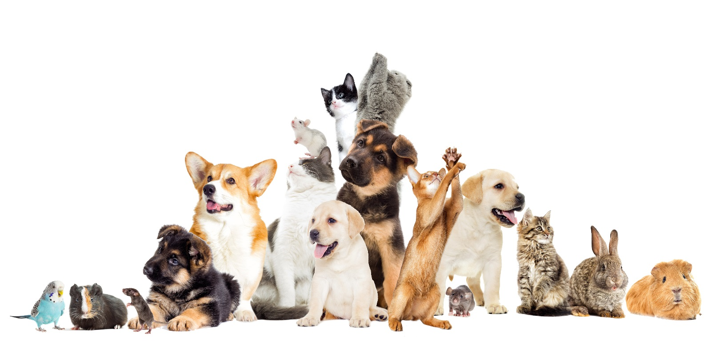

**Domestic Animal Management Plan 2017-2021**

**Banyule City Council**

**Animal Management**

BAN CC sml logo hori rev**Table of Contents**

# 

# Table of Contents

Table of Contents 2

Domestic Animal Management Plans 3

Introduction 5

Demographic and City Profile 7

Current Programs and Services 8

SECTION 1 – Training of Authorised Officers 9

SECTION 2 – Nuisance Complaints 16

SECTION 3 – Dog Attacks and Dog Confinement 24

SECTION 4 – Dangerous, Menacing and Restricted Breed Dogs 26

SECTION 5 – Overpopulation and High Euthanasia 30

SECTION 6 – Domestic Animal Businesses 34

SECTION 7 – Other Matters 36

SECTION 8 – Review of Plan and Annual Reporting 39

Bibliography/References 39

# 

# 

# 

# Domestic Animal Management Plans

Section 68A of the Domestic Animals Act requires Council to prepare a domestic animal management plan:

1. Every Council must, in consultation with the Secretary (of the Department of Economic Development, Jobs, Transport and Resource), prepare at four year intervals a domestic animal management plan.
2. A domestic animal management plan prepared by a Council must -
   1. set out a method for evaluating whether the animal control services provided by the Council in its municipal district are adequate to give effect to the requirements of this Act and the regulations; and
   2. outline programs for the training of authorised officers to ensure that they can properly administer and enforce the requirements of this Act in the Council's municipal district; and
   3. outline programs, services and strategies which the Council intends to pursue in its municipal district -
3. to promote and encourage the responsible ownership of dogs and cats; and
   1. to ensure that people comply with this Act, the regulations and any related legislation; and
   2. to minimise the risk of attacks by dogs on people and animals; and
   3. to address any over-population and high euthanasia rates for dogs and cats; and
   4. to encourage the registration and identification of dogs and cats; and
   5. to minimise the potential for dogs and cats to create a nuisance; and
   6. to effectively identify all dangerous dogs, menacing dogs and restricted breed dogs in that district and to ensure that those dogs are kept in compliance with this Act and the regulations; and
   7. provide for the review of existing orders made under this Act and local laws that relate to the Council's municipal district with a view to determining whether further orders or local laws dealing with the management of dogs and cats in the municipal district are desirable; and
   8. provide for the review of any other matters related to the management of dogs and cats in the Council's municipal district that it thinks necessary; and
   9. provide for the periodic evaluation of any program, service, strategy or review outlined under the plan.
4. Every Council must -
   1. review its domestic animal management plan annually and, if appropriate, amend the plan; and
   2. provide the Secretary with a copy of the plan and any amendments to the plan; and
   3. publish an evaluation of its implementation of the plan in its annual report.

**Statutory Compliance**

Council is required to provide an animal management service to ensure that community amenity and safety is not compromised by animals, customer requests and complaints are responded to, and that all relevant Acts, Regulations and Local Laws are enforced. In doing so, Council must comply with the following Acts and Regulations:

* Domestic Animals Act and Regulations 1994;
* Impounding of Livestock Act 1994;
* Prevention of Cruelty to Animals Act 1986;
* Infringements Act 2005; and
* Local Government Act 1989.

And have regard to applicable guidelines and standards including:

* Code of Practice for the Management of Animals in Shelters and Pounds;
* Code of Practice for the Operation of Pet Shops;
* Code of Practice for the Operation of Breeding and Rearing Establishments;
* Code of Practice for the Operation of Boarding Establishments;
* Code of Practice for the Operation of Dog Training Establishments; and
* Code of practice for the Operation of Greyhound Establishments.

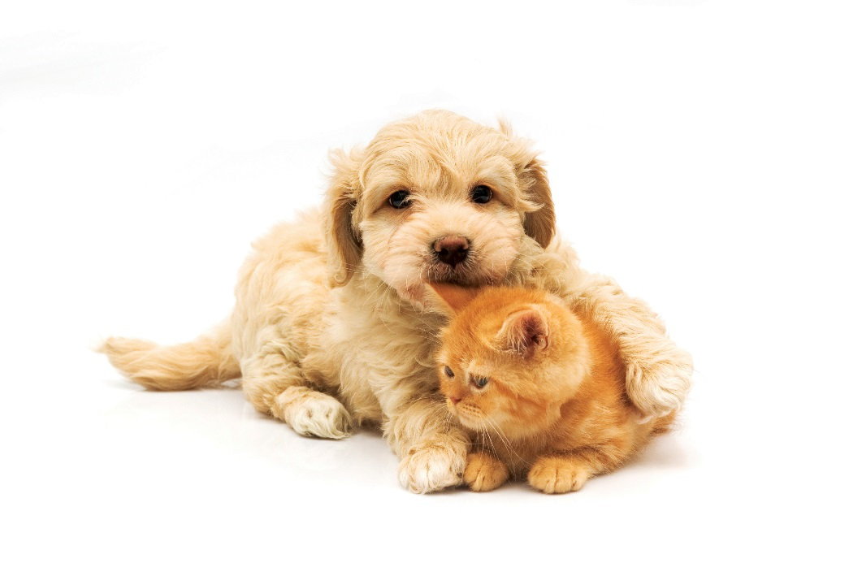

# Introduction

Companion animals play an important role in today’s society, be it for companionship, work, entertainment or sport, and Council wants people to enjoy them.

Pets that are well managed cause few problems and rarely come to the attention of Council. Unfortunately, when animals are acquired with little forethought or for the wrong reasons, or when they are left unsupervised, problems occur.

The State Government introduced the Domestic Animals Act in 1994 which, with subsequent amendments has a significant impact on the responsibilities of individual pet owners, including the way cats and dogs are housed and controlled. The Act and its Regulations also make it compulsory for owners to register all dogs and cats over three months of age, and control animal businesses such as pet shops and breeders.

While some in the community think of Animal Management Officers as simply ‘dog catchers’, this is a term that fails to capture the significant, diverse and often dangerous work of these officers.

On a daily basis, their work in responding to calls requires compassion, effective communication and patience as they provide advice, education and assistance. Where necessary, they also enforce the Act, which may result in criminal charges. For the most part, residents are happy to assist officers and will confine stray animals for collection, knowing that they will be humanely treated and wherever possible returned to their owners, or rehoused in a good home by Council’s service provider, rescue groups or other stakeholders.

While council has the responsibility of administering the Act, it recognises the need to promote responsible pet ownership, provide supportive programs and meet community expectations. This plan is a base for Council to provide high quality animal services and programs now and into the future.

This Plan was developed by Banyule Council’s Animal Management Officers (AMOs) in consultation with key stakeholders.

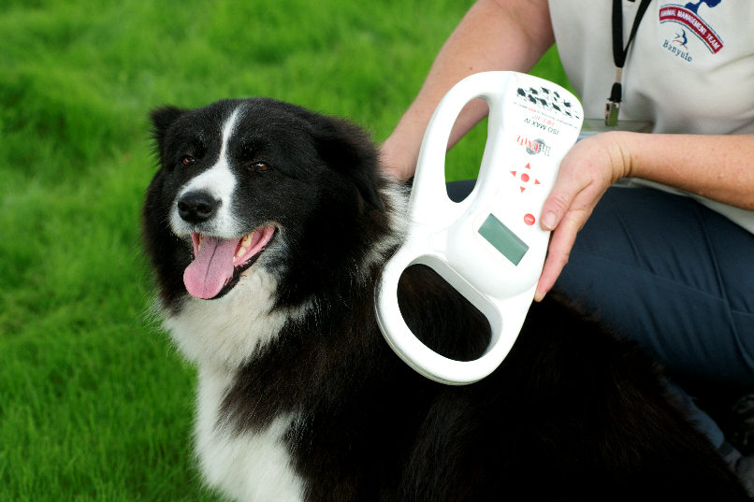

# 

# Demographic and Banyule Profile

**Context**

The Domestic Animals Act 1994 establishes a legislative requirement for Local Government to prepare, implement and annually report on its Domestic Animal Management Plan.

Banyule Council’s Plan has been prepared in consultation with Councillors, Council Officers and the community and seeks to balance the competing needs of animal owners, the broader community and the animals that share people’s lives. Council recognises the positive health and wellbeing benefits that arise from pet ownership.

**Demographic and Banyule Profile**

The 20 suburbs of Banyule cover 63 square kilometres, located between 7 and 21 kilometres to the north-east of Melbourne’s CBD.  
Banyule comprises the suburbs of Bellfield, Briar Hill, Bundoora, Eaglemont, Eltham North, Greensborough, Heidelberg, Heidelberg Heights, Heidelberg West, Ivanhoe, Ivanhoe East, Lower Plenty, Macleod, Montmorency, Rosanna,   
St Helena, Viewbank, Watsonia, Watsonia North and Yallambie. Banyule is mainly residential in character, with pockets of industrial and commercial development, as well as a number of major facilities such as the Austin, Repatriation and Warringal hospitals, and major shopping centres at Heidelberg, Ivanhoe and Greensborough with smaller shopping centres in Watsonia, Rosanna, Eaglemont and East Ivanhoe. This balance of land use helps maintain economic viability and employment.

Three major waterways traverse Banyule, with the Yarra River in the east, Plenty River in the centre and Darebin Creek on its western boundary, each with their own characteristics and environmental significance. The lay of the land varies from relatively flat plains to steep hills.

The 2016 Census recorded 121,865 Banyule residents (118,304 in the 2011 Census), with 48.6% male and 51.4% female and a median age of 39. Banyule’s indigenous population is 0.6% of the total population.

**Purpose of the Domestic Animal Management Plan**

The purpose of this Plan is to detail the arrangements that Council has to help manage domestic animals and work towards improved animal management in Banyule.

The aim of the Plan is to:

* Support and facilitate the benefits that animal ownership and companionship has on the health and wellbeing of residents.
* Educate residents about accepted standards of animal welfare, including the care, feeding and physical wellbeing of domestic animals.
* Manage nuisance complaints about animals, which are impacting on other residents.
* Ensure that the keeping of domestic animals does not compromise accepted standards of public health or safety.

# Current Programs and Services

Council currently has the following generic animal management programs and services:

|  |  |
| --- | --- |
| Program/Service | Service Level |
| Identification and registration of dogs and cats | * Annual registration renewals sent in March |
| Enforcement of registration requirements | * Regular reminders in the Banyule Banner and local newspapers * Annual reminder notices and doorknock inspection campaigns |
| Investigation of nuisance animal complaints | * Initial response within 5 days * Follow up as required |
| Investigations of dog attacks and dangerous/menacing dog complaints | * Within 30 minutes |
| Dogs wandering at large | * Within 30 minutes if considered an emergency and otherwise within 1 hour |
| Declared dog property inspections | * Conducted annually |
| Cat Desexing Program | * Twice a year |
| Domestic animal business inspections | * Conducted annually, renewal due 10 April |
| Pound open for collection of animals | * 7 days a week |
| Excess Animal Permit renewals and new permit inspections | * Annually on 31 May |
| Promotion of responsible animal ownership | * Media releases, Banyule Banner, social media and other promotional channels |
| Cat trapping | * Cat trap cages available |
| Customer Service | * Ongoing updates throughout the year to Customer Service to keep staff informed of new processes |
| After hours emergency service for animals | * Runs 365 days 24 hours a day |

# 

# SECTION 1 – Training of Authorised Officers

**Summary**

It is critical that all staff involved in animal management have the knowledge and skills needed to carry out their work as well as having the necessary authorisations and delegations.

**Current Situation**

The current training of officers include:

|  |  |  |  |  |  |  |  |
| --- | --- | --- | --- | --- | --- | --- | --- |
| **Officer** | **Cert IV in Animal Control** | **Cert IV in Animal Welfare** | **Cert IV in Government/Statutory Compliance** | **ATC – Investigation and Case Management** | **ATC –**  **Municipal Law Enforcement** | **ATC –**  **Prosecutors or Advanced Prosecutors** | **Diploma of Frontline Management** |
| 1. | x |  |  | x | x |  | x |
| 2. | x |  |  | x |  |  | x |
| 3. |  |  | x | x | x | x | x |

|  |  |  |  |  |  |  |  |
| --- | --- | --- | --- | --- | --- | --- | --- |
| **Officer** | **Statement and Interview Course** | **MLS –**  **Report Writing Course** | **Animal Handling Training -Dogs** | **Animal Handling Training – Larger Animals** | **DPI/ MAV Training Days** | **Cert 3 Dog Behaviour and Training** | **Dog Bite Prevention Training -**  **Canine Services International** |
| 1. | x | x | x | x | x |  | x |
| 2. | x | x | x | x | x | x | x |
| 3. | x | x | x | x | x |  | x |

**Other training includes:**

Microchip Implanting Training Train the Puppy Trainer

Customer Service Training, including dealing with difficult people RSPCA Conferences

Manual Handling training OHS Dangerous Dog Manual Handling Canine DNA Dog Attack Collection Techniques First Aid for Pets

Equal Opportunity Training Dog Breed Identification Training

Pets in Domestic Violence

Manual Handling Training

Stress Management Training

Managing Potentially Violent Clients

**Future Plans**

**Objective 1:** To ensure all staff involved in animal management have the knowledge and expertise to carry out their duties and functions of Council.

|  |  |  |  |
| --- | --- | --- | --- |
| **Activity** | **Responsible Officer** | **When** | **Evaluation** |
| Conduct annual performance reviews and identify further training needs for individual officers | Coordinator/ Senior | Annually | Performance reviews completed |

**Objective 2:** To successfully induct and manage new staff.

|  |  |  |  |
| --- | --- | --- | --- |
| **Activity** | **Responsible Officer** | **When** | **Evaluation** |
| Monitor performance and provide guidance to employees where needed | Coordinator/ Senior | Ongoing | Council Induction and Performance management |

**Summary**

Identifying and registering domestic animals is seen as the cornerstone of a successful animal management program.

Pet registration also helps us get your dog or cat home. The chief frustration of AMOs Animal Management Officers is when an animal is micro chipped but the owners have moved and not updated their details. If a dog or cat is not registered with Council and its microchip details are incorrect, it makes it very difficult for us to let an owner know where their animal is if it gets out.

Identification of animals is also critical in investigating complaints.

We will be attempting to increase the numbers of registered animals in Banyule, particularly in relation to cat registrations, by using a variety of methods.

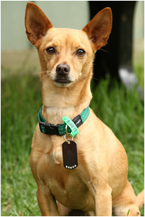

**Current Situation**

As at 31 July 2017, Banyule has 13,013 dogs and 5,198 cats registered, a slight increase on the previous year.

|  |  |  |
| --- | --- | --- |
|  | **2016/17** | **2015/16** |
| Registered dogs | 13,013 | 12,674 |
| Registered cat | 5,198 | 5,109 |

**Council Policies and Procedures**

A fixed reduced registration fee for de sexed and microchipped animals have been set for the current financial year. This fee is reviewed and adjusted annually in line with all of Council’s fees and charges.

During the second half of the registration period from 10 October, half yearly fees apply for new registrations.

**Current Activities for Registration**

Our current activities for pet registration, including actions from our previous plan, include:

* Providing for online registration/renewal.
* Promoting the benefits of registration and identification, chiefly being able to reunite a lost animal with its owner.
* Using Council’s website to provide information to residents on registration.
* Providing, in conjunction with local vets, subsidised desexing - (supplying owners with Australian Veterinary Association desexing vouchers).
* Distributing registration and identification brochures, factsheets and other materials to pet owners.
* Issuing annual registration renewal notices and following up non-renewals, including by sending additional letters, calling owners, and by targeted visits to properties.
* Ensuring that information about sold/rehoused animals from domestic animal businesses (pet shops, shelters) is followed up for registration.
* Ensuring that registration and identification compliance are checked as part of managing complaints about animals.
* Ensuring that registered dogs and cats are returned home after hours, with unregistered pets impounded, with compulsory registration prior to leaving the pound.
* Ensuring all authorised officers have a microchip scanner in vehicles.

Keeping records of animals impounded and found, including injured or dead animals, and notifying owners of injured or dead animals to seek veterinary treatment or help provide ‘closure’ for those that have died. Banyule’s Cleansing Department also has a microchip scanner to scan dogs and cats when they are called to pick up an animal killed on roads.

* Ensuring that pet shops, breeders, shelters, vets are provided with information on registration and identification (for example, microchipping) responsibilities under the Act.
* Regularly updating/auditing Council’s registration database to ensure information is current (for example, amending data to reflect notifications of deceased animals, changes of address, changes of owner) to ensure owners are not distressed or annoyed by receiving unnecessary or incorrect renewal notices, or no renewal notice.
* Ensuring that owners are charged the correct State Government levy on each registration after Council has determined its own fees.
* Promoting registration and the wearing of registration tags via Council publications and other media. This is done using ’good news’ stories about pets being returned to owners because they were microchipped and registered.
* Having a reduced fee category in the registration fee structure for dogs and cats under 6 months old. Some vets do not believe that pets should be desexed until they are 6 months old, so this strategy still encourages pet owners to register their pets without paying a full fee for the first year.

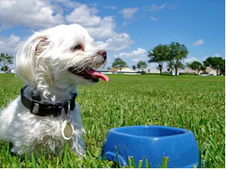

**Objective 1:** To increase dog and cat registration rates by 5% each year via education and promotion.

|  |  |  |  |  |  |
| --- | --- | --- | --- | --- | --- |
| **Activity** | **Responsible Officer** | | **When** | | **Evaluation** |
| Continue supplying desexing vouchers to low income earners | Coordinator | Ongoing | | Number of vouchers redeemed | |
| Include registration, identification and renewal information in rates notices, newsletters, on the web and via social media | Coordinator | Ongoing | | Number of promotional activities undertaken | |
| Include registration forms, registration and identification requirements, brochures and fact sheets in kits for new residents | Communications | Ongoing | | All new resident kits contain pet registration information | |
| Promote registration and the wearing of registration tags via appropriate Council communication channels, particularly by using ‘good news’ stories of pets being returned to their owners because of microchipping and registration | AMOs / Communications | Ongoing | | Number of promotions | |
| Automatic registration up until next renewal period of cats being desexed via Council’s program | AMOs | Twice a year | | Number of cats registered each year | |

Objective 2: To increase pet registration by 5% via compliance initiatives

|  |  |  |  |
| --- | --- | --- | --- |
| Activity | Responsible Officer | When | Evaluation |
| Ensure all registration renewals are followed up each year, with failure to renew infringements issued when applicable | Coordinator | Yearly | By September/October of each year, all owners have received a renewal, a final reminder and, if still no renewal, the property is visited to determine if the animal is residing there |
| Ensure all animals identified from a complaint are registered | AMOs | Ongoing | All details are recorded on Customer Service Requests when AMOs deal with the complaint |
| Ensure a 5% increase in dogs and cats registrations are entered on system each year | Coordinator | Yearly | 5% annual increase |
| Use text messaging for pet registration renewal reminders | IT | Yearly | Decrease in number of registration renewal checks by contractor |
| Pet registration renewals emailed to residents who opt in | Coordinator | Yearly | Number of email renewals sent and response rate |

**Objective 3:** To increase pet registration rates by 5% each year using improvements in technology.

|  |  |  |  |  |
| --- | --- | --- | --- | --- |
| **Activity** | **Responsible Officer** | | **When** | **Evaluation** |
| Increase use of mobile technology, so AMOs can, for example, search pet registration and customer request databases to identify properties where animals are not registered | | AMOs | Daily | Increased number of animals identifiable by registration |
| Provide online registration for pets | | AMOs/ Coordinator | April 2018 | Number of residents using online registration |

# 

# SECTION 2 – Nuisance Complaints

**Summary**

The most common nuisance complaints received by Council relate to barking dogs. (Dog at large and dog attacks are dealt with under Section 4 of this plan as they are not categorised as nuisance complaints.)

The majority of time AMOs spend dealing with complaints relates to barking dogs and it is therefore critical that AMOs strategies and activities are in place to reduce the number of complaints from the public. Barking dog complaints require far more time for the AMO to resolve given the need to substantiate the complaint, which can often lead to frustration by the complainant and dog owner.

**Current Situation**

Between 1July 2016 and the 30 June 2017, Council received the following number of complaints

|  |  |  |
| --- | --- | --- |
| **Complaint type** | **2016/17** | **2015/16** |
| Nuisance Cats | 221 | 293 |
| Responsible Pet Ownership | 284 | 249 |
| Animal Special Requests | 163 | 180 |
| Barking Dog | 319 | 359 |
| Found Dog | 518 | 555 |
| Found Cat/Cat in Cage | 185 | 139 |
| Lost Cat Reports | 99 | 98 |
| Lost Dog Reports | 216 | 215 |
| Stray Livestock/Farm Animal | 2 | 4 |
| Dog Attack | 73 | 87 |
| Dog at large/ Rushing/ Menacing | 256 | 216 |

**Our current Orders, Local Laws, Council Policies and Procedures**

**Dogs and Cats in Public Places Orders**

In line with its statutory powers under section 26 of the Act, Council has an existing Order for Dogs and Cats in Public Places which was adopted by Council in 1998.The Order requires that dogs are to be kept on leash when on a Council road or footpath and within 5 metres of a designated shared footway, children’s playground or barbeque area.

Dogs and cats are prohibited from entering environmentally sensitive areas as designated by signs in the following parks and reserves:

Brown’s Nature Reserve, Greensborough(as per existing covenant)

Banyule Flats Wetland and Banyule Billabong, Heidelberg

Horseshoe, Reedy and Bailey Billabongs in **Wilson Reserve, Ivanhoe *See Amendment*  \***

Warringal Swamplands, Heidelberg

Yandell Reserve (within already fenced areas), Greensborough

St Helena Bush Reserve (within already fenced areas), St Helena

Rockbeare Park, Ivanhoe

For the purpose of any order made under section 26 of the Domestic Animals Act 1994, within the City of Banyule and as a guide for implementation, a dog shall be deemed to be under effective control of its owner if;

1. it is within 75 metres (clear and unobstructed) of its owner; and
2. will return to its owner upon command.

**Local Laws**

Banyule City Council General Local Law Number 1 was reviewed in 2014 and was adopted formally by council, with effect on 15 April 2015. Part 10 of the Local Law Number 1 deals with the keeping and control of animals within Banyule. The main objectives are to control the number and type of animals and to control animal behaviour to minimise adverse impact on other residents.

It is an offence to keep more than a prescribed number of animals without the written consent of Council via a permit.

As at 30 June 2017, there were 86 households with active excess animal permits registered. This figure changes regularly due to residents moving in and out of Banyule. These permits are renewed annually on 31 May.

|  |  |  |
| --- | --- | --- |
|  | 2016/17 | 2015/16 |
| Number of Excess Permits issued/current | 86 | 80 |

The table below lists the maximum number of animals allowed to be kept without the need for a permit. Permits are also required for goats, horses, roosters and other animals.

|  |  |
| --- | --- |
| **Type of Animal** | **Maximum Allowed** |
| Dogs | 2 |
| Cats | 2 |
| Poultry | 10 |
| Pigeons and/or Domestic Birds | 20 |
| Guinea Pigs | 4 |
| Rabbits | 4 |
| Rooster | 0 |

The conditions in which excess animals must be kept are:

(a) The ground surrounding the place where the animal is kept is free from dry grass,

weeds, refuse, rubbish or other material capable of harbouring rodents or

vermin;

(b) The place where the animal is kept and the surrounding area is well drained;

(c) All food for consumption by the animal is kept or stored in a vermin proof

receptacle;

(d) Any area where the animal is kept is thoroughly cleaned as often as necessary to

keep the area clean and sanitary at all times;

(e) All manure, excrement, refuse or rubbish produced or accumulated by the animal

is disposed of, as soon as practicable, so that it does not cause a nuisance or

create a condition which is offensive or dangerous to health.

**Control of Noisy Animals and Birds**

An *owner* or *occupier* of any *land* where an *animal* is kept or allowed to remain must

not allow the *animal* to make noises or sounds which will create a nuisance that may

unreasonably or adversely affect:

(a) The peace and comfort of any *person*; or

(b) The amenity of any other *land*.

**Council Policies and Procedures**

**Current Activities**

Our current educational, promotional and compliance activities include:

**All nuisance complaints**

* Provide information on Council’s website and in its newsletters relevant Local Laws and Orders, types of nuisance and how to report and record ongoing nuisance (for example via a barking dog diary, cat trespass) to support complaints.
* Provide one on one advice, education and assistance to animal owner.
* Distribute relevant brochures, factsheets and other materials regarding nuisance issues.
* Record all nuisance complaints on the Customer Request Management system.
* Investigate nuisance complaints effectively.
* Ensure nuisance investigation timeframes are as short as possible to reduce complainant’s frustration.
* Review Council policies and procedures relating to nuisance.
* Ensure notices to comply, notices of objection, infringements, and prosecutions are in line with Council policies, procedures and guidelines.

**Cat trespass complaints**

The major issue of concern about cats are unowned or stray cats that roam the

neighbourhood fighting with other cats over territory, and generally creating a nuisance by spraying and defecating on private property.

Throughout the kitten season, which is generally in spring but can go longer depending on weather, Council receives many complaints about cats with kittens taking up residence on private property. In many cases, residents feel sorry for the animals and start leaving food for them, which can exacerbate the problem. Cats are a large concern for Banyule and there needs to be more cat awareness and education.

**Current activities relating to cat trespass:**

* Strongly encouraging desexing of pets to reduce wandering and organising desexing on the owners behalf, along with animal transport if required.
* Actively encouraging cat owners to confine their cats to their property to enhance animal welfare and reduce the incidence of nuisance.
* Providing cat cages, and requirements relating to trapping, to local residents to trap cats trespassing on their property in order to reduce the impact of stray/unowned cats.
* Ensuring the cat trapping program is undertaken in the most humane way, with cats picked up as soon as practicable after capture to reduce animal distress. Council recommends that all residents set traps before going to bed at night and call Council first thing in the morning for a pick up.
* Continuing to issue excess animal permits to reduce the possibility of nuisance complaints.
* Investigating nuisance cat complaints to mitigate ongoing complaints, including letterbox drops to homes surrounding that of the complainant.
* Work with residents experiencing mental illness/animal hoarding to reduce the number of pets they have and ensure those they keep are healthy, manageable and registered.
* Work with the Department of Housing to ensure compliance in relation to their properties and known hoarders.

Council Officers will:

* Supply cat traps to residents’ properties and collect any trapped cats within as short a time as possible to minimise distress to the animal;
* Assist the resident to take formal ownership of stray cats by organising and paying for micro chipping and desexing through Council’s bi-annual desexing program.



**Barking Dog Complaints**

Barking dog complaints are the most common type of complaint and take the most time to resolve variety of methods. Common reasons for dogs barking include:

* Wrong choice of dog breed

• Lack of exercise

• Boredom, loneliness and frustration

• Feeling under threat (another dog, or loud noise such as thunder or fireworks)

* Poor living conditions
* Multi-unit developments (closer living conditions)

• Ill health

Complainants who contact Council about a barking dog will be asked to speak to the dog’s owner in the first instance to open the line of communication between the parties and to see if anything can be done to stop the dog barking.

Complainants are mostly reluctant to discuss issues of barking dogs with neighbours, but Council recognises that communication is critical to resolving issues.

**Current activities relating to barking dogs:**

* Constantly reviewing processes regarding neighbourhood complaints about nuisance barking.
* Providing information on the causes of excessive barking, including separation anxiety, boredom, external stimuli, territorialism, communication with other dogs etc.
* Encouraging owners of barking dogs to seek advice from Council/professional dog trainer/animal behaviourist on how to reduce their dog’s barking.
* Encouraging complainants to contact owner of a barking dog and advise them of their concerns as a first step in resolving the issue before starting the investigation process.
* Including mediation through the Dispute Settlement Centre as part of a new process to open lines of communication, with the hope that residents can work together on a solution.



**Dog litter complaints**

Under Local Law 10.6 Dog Excrement, a dog owner must:

(a) Remove and dispose of faeces deposited by their dog; and

(b) Carry a litter device and must produce such litter device upon request of any Authorised Officer, in any public place.

**Current activities relating to dog litter activities currently undertaken:**

* Advising dog owners of the legal requirements relating to cleaning up dog litter by distributing educational materials (see ‘All nuisance’ section for methods) and, during patrols in parks and public places, providing dog walkers doing the right thing with information, dog ‘pooch pouches’ and leads.
* Continuing to enforce the collection and disposal of dog litter by the owner/person in charge of the dog as well as the requirement to carry a suitable collection means.

**Dog Parks**

* In 2007, the AMOs investigated the possibility of including a fully fenced dog park in Banyule, incorporating this into the Public Open Space Strategy, which led to funding for a feasibility study. This early work was successful, with Banyule now having four fenced dog parks:
* Price Park, Lyon Road, Viewbank
* Ford Park, Banksia Street, Bellfield
* Malahang Reserve, Oriel Road, Heidelberg West
* Malcolm Blair Reserve, Karingal Drive, Eltham

These parks are fully fenced off-lead exercise areas with park benches, dog waste bins and drinking fountains with dog bowls. They are fully maintained and serviced by Council’s Parks and Gardens Department.

**Objective 1:** Reduce the number of nuisance complaints via education

|  |  |  |  |
| --- | --- | --- | --- |
| **Activity** | **Responsible Officer** | **When** | **Evaluation** |
| Provide more information to residents about the Dispute Settlement Centre and, where necessary, organise mediation, providing a summary of the issue to the mediators with details of both parties with their consent. | AMO handling the investigation | Only if both parties agree to the mediation | Feedback on the mediation from both parties and reduction in ongoing complaints |
| Park Patrols | AMOs | Ongoing | Number of park patrols and compliance and awareness |
| Review enforcement policies and procedures | AMO | Ongoing | Number of policies and procedures reviewed to ensure compliance with legislation |
| Provide information about cat enclosures and cat nuisance issues to cat owners | AMOs | Ongoing | Reduction in number of nuisance cat complaints and impounded cats |
| Promote fully fenced dog parks within Banyule | AMOs | Ongoing | Number of promotions undertaken |
| Develop a new Barking Dog Process | AMOS/ Coordinator | June 2018 | Completion of Barking Dog Process |

**Objective 2:** Reduce the number of nuisance complaints using compliance

|  |  |  |  |
| --- | --- | --- | --- |
| **Activity** | **Responsible Officer** | **When** | **Evaluation** |
| Continued implementation and promotion of the cat desexing program in Banyule | AMOs/ Coordinator | April and August annually | Number of cats desexed/microchipped |
| Implement nuisance abatement activities outlined in the ‘Who’s for Cats?’ program: promote the campaign to ensure that people who are feeding cats take full ownership of cats; website link | AMOs | Ongoing | Increase in cat registration numbers |
| In conjunction with residents, trap semi owned/owned cats in response to trespass complaints | AMOs | Ongoing | Increase in cat registrations, fewer cat trespass complaints and reduction in cats impounded |
| Ensure complaints are dealt with effectively, efficiently and satisfactorily | AMOs | Ongoing | Weekly reporting of initial response for animal management complaints |

**Objective 3:** Use technology to assist in reducing and resolving nuisance complaints

|  |  |  |  |
| --- | --- | --- | --- |
| **Activity** | **Responsible Officer** | **When** | **Evaluation** |
| Investigate web-based online complaint lodgement, including providing better information about what constitutes a nuisance | AMOs/ Coordinator/ Communications | June 2018 | Online complaints launched and number of online complaints received |

# 

# SECTION 3 – Dog Attacks and Dog Confinement

# Summary

A critical role for Council is to minimise the number of dog attacks due to the potential damage that dogs can inflict on other animals and people.

It is important that Council raises community awareness on how to reduce the risk of a dog attack.

The identification of animals, including declared dogs, is important as is ensuring dogs are contained to their property at all times.

**Current Situation**

Customer Service Requests for dog attacks include those causing minor injury to those causing serious injury. Analysis of the data shows that most attacks were rushes by dogs with no injuries eventuating.

|  |  |  |
| --- | --- | --- |
| Complaint type | Total  30 June 2017 | Total  30 June 2016 |
| Dog Attack | 73 | 87 |
|  |  |  |
| Rushing/Wandering at Large and Menacing dogs | 256 | 216 |
| Dog Found/Containment | 518 | 555 |

**Our current Orders, Local Laws, Council Policies and Procedures**

Nil

**Current Activities**

Our current educational, promotional and compliance activities include:

* Raising awareness of the risk of dog attacks in the home, in the street and in parks, and reducing these risks by:
* distributing brochures, factsheets and other materials regarding dog attacks;
* providing information with registration renewals and in new resident packs
* Promoting effective confinement and control of dogs.
* Promoting desexing of dogs to reduce aggressive tendencies and wandering.
* Promoting early socialisation of dogs with other animals and humans.
* Promoting regular exercise of dogs.
* Responding to dog attack reports within 30 minutes (the top priority for AMOs).
* Responding to dog wandering complaints.
* Providing an afterhours number for the community to report dog attacks.
* Prosecuting owners for breaches of the Act.
* Ensuring all reported dog attacks are recorded and investigated, meeting all points of proof provided in the Act, seizing dogs and prosecuting owners in accordance with the Animal Act 1994.
* Introduced more fully fenced dog parks within Banyule
* Producing a brochure on ’Victims of dog attacks’ to provide information on what Council can and can’t do under the legislation.

**Future Plans – Dog attacks and Dog Confinement**

**Objective 1:** Reduce the incidence of wandering dogs and dog attack in the community through education.

|  |  |  |  |
| --- | --- | --- | --- |
| **Activity** | **Responsible Officer** | **When** | **Evaluation** |
| Provide information on Responsible Dog Ownership Program | AMOs | Ongoing | Materials provided on website and number of people using the Responsible Dog Ownership Program |
| Provide residents with information on implications for their dog and themselves if their dog attacks a person or animal | AMOs | Ongoing | Reduction in number of dog attacks |
| Promote the importance of training, socialising and desexing dogs at an early age | AMOs | Ongoing | Reduction in number of dog attacks |
| Encourage and provide residents with information on how to report dog attacks whether on public or private property | AMOs/ Communications | Ongoing | Amount of information available via a range of channels |

**Objective 2 -** Reduce the incidence of wandering dogs and dog attack in the community through compliance.

|  |  |  |  |
| --- | --- | --- | --- |
| **Activity** | **Responsible Officer** | **When** | **Evaluation** |
| Patrol and identify properties where containment may be an issue | AMOs | Ongoing | Increased compliance |
| Report outcomes of all dog attack prosecutions to local media to raise awareness of dog attacks and Council’s actions | Coordinator | Ongoing | Number of stories sent to media and number published |
| Concentrate patrols in high risk areas | AMOs | Ongoing | Increased compliance |

**Objective 3:** Reduce the incidence of wandering dogs and dog attacks in the community through technology.

|  |  |  |  |  |  |  |
| --- | --- | --- | --- | --- | --- | --- |
| **Activity** | | **Responsible Officer** | **When** | | **Evaluation** | |
| Use Council’s social media to educate the community on the effects of wandering dogs and dog attacks | AMO | | | Ongoing | | Number of social media posts |

# SECTION 4 Dangerous, Menacing and Restricted Breed Dogs

**Summary**

A **restricted breed dog** is defined as a dog that fits the [Approved Standard for Restricted Breed Dogs in Victoria](http://agriculture.vic.gov.au/pets/dogs/restricted-breed-dogs/standard-for-restricted-breed-dogs). These may be pure or cross bred American Pit Bull Terriers (or Pit Bull Terriers), Perro de Presa Canarios (or Presa Canario), Dogo Argentinos, Japanese Tosas, or Fila Brasileiros.

While restricted breed dogs may not have attacked a person or animal or displayed signs of aggression, they are considered a higher risk to community safety than other breeds.

Only the American Pit Bull Terrier (or Pit Bull Terrier) and one Dogo Argentino is known to be in Victoria. Cross breeds of restricted breeds are also considered a restricted breed dog.

The Parliamentary Inquiry into restricted breed dog legislation was established in 2015. The Economy and Infrastructure Committee undertook a detailed investigation into the management of different breeds of dog, and into dog attacks, their causes and prevention strategies.  The Inquiry received 502 written submissions and heard from 16 organizations and individuals at public hearings.  The Inquiry's report was published in March 2016, with 31 recommendations.

The State Government agrees or agrees in principle with 25 of the Inquiry's recommendations, including that the Domestic Animals Act 1994 (Act) be amended to allow the registration of restricted breed dogs, while retaining all other restrictions related to restricted breed dogs.

The proposed amendment to the Act allows for the registration of restricted breed dogs but does not change any of the strict controls applying to restricted breed dogs that are currently in place. Restricted breed dogs will still be required to:

* be desexed;
* be kept on a leash and muzzled at all times when in public;
* securely confined to their owner’s back yard; and
* Wear a red and yellow striped collar at all times.

Properties containing a restricted breed dog must display a specific turquoise warning sign at the entrance to the property indicating that a restricted breed dog is housed there.Bans on breeding, adopting or transferring the ownership of restricted breed dogs will also remain in place.

A **dangerous dog** is a dog that has attacked a person or animal or which, in the opinion of a Council, has caused serious injury to a person or another animal.

The owner of a dangerous dog has to meet stronger control provisions, including erecting an approved housing enclosure meeting the requirements of the Domestic Animal Regulations 2015

A dog is said to be a **menacing dog** if the dog causes a non-serious bite injury to a person or animal. This is in addition to the existing power to declare a dog to be menacing if it rushes at or chases a person.

A ’Rush’ means that a dog has approached a person within 3 metres in a menacing manner, including by displaying aggressive behaviour such as snarling, growling and raising the hackles.

A menacing dog declaration can be upgraded to a dangerous dog declaration if the owner of the menacing dog has been issued with two infringement notices for failing to comply with requirements, such as leashing or muzzling their dog while in public places.

It is important that the properties where these dogs reside are inspected regularly to ensure that all requirements of keeping a declared dog are being met. These dogs have the potential to cause great harm so it is important from a community safety perspective that they are kept in accordance with the Act and Regulations.

**Current Situation – Dangerous, Menacing and Restricted Breed Dogs**

* All dogs that have been declared a menacing dog, restricted breed or dangerous dog are inspected annually. The inspections are to ensure that the animal is being housed in accordance with the legislative requirements under the Act and regulations.
* All declared dogs are registered on the Victorian Declared Dog Registry

**Our current Orders, Local Laws, Council Policies and Procedures**

**Current Activities**

Our current educational, promotional and compliance activities include:

* Ensuring that all owners of declared dogs are aware of their obligations under the Act regarding identification and keeping these dogs by providing them with relevant sections of the Act, brochures and factsheets (information kit).
* Ensuring all declared dogs are accurately registered on the Victorian Declared Dog Registry and that details regarding change of owner, change of address, death of dog are updated as soon as possible ([www.ddvic.registry-service.com](http://www.ddvic.registry-service.com)).
* Ensuring that declared dog registration information on the Victorian Declared Dog Registry and Council’s Register is the same.
* Performing annual inspections of all properties with declared dogs to ensure compliance with the Act and regulations.
* Following-up any non-compliance issues until the dog owner complies.
* Responding to complaints regarding declared dogs within 30 minutes.
* Ensuring the necessary enforcement action is taken for known problem dogs and, where necessary, they are declared to minimise the risk of future occurrences.

**Future Plans- Dangerous, Menacing and Restricted Breed Dogs**

**Objective 1:** Identify all declared dogs in Banyule using education.

|  |  |  |  |  |  |
| --- | --- | --- | --- | --- | --- |
| **Activity** | **Responsible Officer** | **When** | | **Evaluation** | |
| Ensure that Council has effective declaration policies and procedures to minimise declarations being overturned at VCAT | Coordinator | | Ongoing | | Policy/procedures developed |
| Ensure the owners of known problem dogs are advised of legal implications, where necessary, to minimise risk | AMOs | | As required | | Number of owners advised as a result of a complaint |
| Report outcomes of all prosecutions (and regular updates on number of infringements) regarding non-compliance with declared dog identification and keeping requirements to local media to raise awareness about declared dogs | AMOs | | Ongoing | | Number of media releases and stories published |

**Objective 2:** Identify all declared dogs in Banyule using compliance.

|  |  |  |  |
| --- | --- | --- | --- |
| **Activity** | **Responsible Officer** | **When** | **Evaluation** |
| Prosecute where necessary any breaches of the Act | AMOs | Ongoing | Increase in number of successful prosecutions |
| Ensure that all declared dogs are inspected on a schedule but annual/random inspection | AMOs | Annual | Number of inspections reported annually |

**Objective 3:** Identify all declared dogs in Banyule using technology.

|  |  |  |  |
| --- | --- | --- | --- |
| **Activity** | **Responsible Officer** | **When** | **Evaluation** |
| Investigate the availability of relevant products which may assist in the safe keeping of declared dogs, such as enclosures, signs etc. | AMOs | Annually | Available products identified |
| Report on the Department of Economic Development Jobs, Transport and Resource Declared Dog Database any dog that has been surrendered for aggression issues. | AMOs | Ongoing | Reports on surrendered dogs |

# SECTION 5 – Overpopulation and High Euthanasia

**Summary**

Banyule Council contracts the Cat Protection Society in Greensborough and the Nillumbik Regional Shire pound as our cat and dog pounds respectively.

**Current Situation - Our current data**

The following impound data from the Cat Protection Society and Nillumbik Regional Shire Pound is detailed below:

|  |  |  |  |  |
| --- | --- | --- | --- | --- |
|  | **Dogs 2016/17** | **Dogs 2015/16** | **Cats 2016/17** | **Cats 2015/16** |
| Impounded | 220 | 191 | 281 | 218 |
| Released to owner | 165 | 126 | 37 | 24 |
| Rehoused | 48 | 61 | 166 | 152 |
| Euthanized | 7 | 4 | 78 | 42 |

Most cats impounded are usually semi-owned strays or semi-feral cats with no microchip details.

**Our current Orders, Local Laws, Council Policies and Procedures**

**Council Policies and Procedures** **- Current Activities**

Our current educational, promotional and compliance activities include:

* Promoting the benefits of desexing – no surprise litters, fewer unwanted animals in the community, fewer animals euthanised, reduced aggression, reduced wandering.
* Continuing registration and microchipping programs to ensure pet cats and dogs can be returned to their owners to reduce euthanasia rates.
* Promoting confinement of animals to owner’s premises to prevent straying.
* Investigating reports of animal hoarding.
* Investigating Customer Request Management reports of unauthorised ‘backyard breeders’ to ascertain whether they should be registered as a domestic animal business.
* Providing cat cages to local residents for trapping cats trespassing on their property.
* Impounding trapped cats at the Cat Protection Society where the animal will be assessed for its suitability for adoption or euthanized.
* Impounding dogs without identification at Nillumbik Shire Pound where the animal can be assessed for its suitability for rehousing.
* Encouraging formal adoption of unwanted cats by assisting the ’carer‘ to have the cat microchipped and desexed under the Australian Veterinary Association’s desexing voucher scheme and providing free registration for newly registered cats.
* Reducing the dumping of unwanted animals by accepting surrendered animals.
* Assisting residents to take responsibility for microchipping new cats and providing desexing vouchers to help control unwanted breeding.
* Providing a link on Banyule Council’s website to the Nillumbik Pound’s page that has photos of impounded animals where no owner has been able to be contacted.

In the 2007 Domestic Animal Management Plan, Council identified that it had a cat overpopulation issue, which created a workload equivalent to a Full Time Officer, with the impound rate at the Cat Protection Society in excess of 800 cats/kittens.

Council introduced a free cat de sexing/microchipping program in August 2013, with 60 cats/kittens desexed. The first program specifically targeted owners who had cats that produced numerous litters that were surrendered to Animal Management Officers, with some cats having up to seven or more litters.

Banyule is committed to reducing the number of unwanted cats and kittens in Banyule. To 30 June 2017, Council has run eight desexing sessions, with approximately 60 cats desexed and microchipped at each session – 480 cats in total. This program assists in achieving full ownership of cats, less straying and critically reducing the number of unwanted litters and therefore euthanasia.

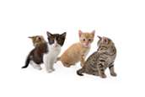

The chart below outlines the impact of just one female cat reproducing.

[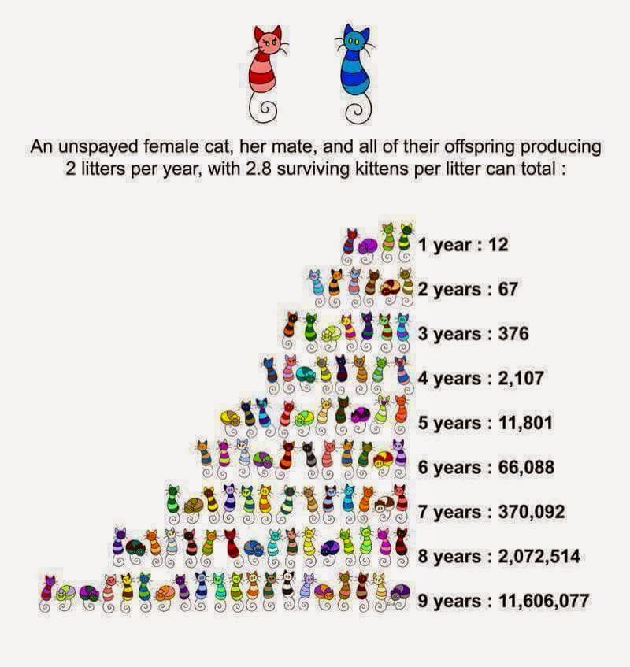](http://www.google.com.au/url?sa=i&rct=j&q=&esrc=s&source=images&cd=&cad=rja&uact=8&ved=0ahUKEwi11qvD4NrUAhUCfLwKHVdgDgQQjRwIBw&url=http://www.harrisonhumane.org/hchs-blog/&psig=AFQjCNHz0uEaBzctTVkTfzfDr7sVlRrdkw&ust=1498540467259710)

**Future Plans**

**Objective 1:** Reduce the amount of euthanasia rates at Council Pound (feral/unowned cats excepted) and increase the percentage of desexed animals on Council’s database through education.

|  |  |  |  |
| --- | --- | --- | --- |
| **Activity** | **Responsible Officer** | **When** | **Evaluation** |
| Continue with the rehousing/adoption program to assist in reducing euthanasia rates | AMOs | Ongoing | Reduction in euthanasia rates |
| Continue to promote the free cat desexing program | Coordinator/ AMOs | April/ August | Number of cats desexed and microchipped |
| Promote desexing during all animal request contacts | AMOs | Daily | The number of desexed dogs and cats on Council’s registration database |
| Raise awareness about the semi-owned cat population by participating in the ‘Who’s for Cats?’ campaign | AMOs | Ongoing | Reduction in number of stray cat complaints and increase in cat registration numbers |
| Involve breed clubs and rescue services to assist in rehousing animals, particularly surrendered animals | AMOs | Ongoing | Links with clubs and rescue services and number of animals rehoused by them |
| Provide vouchers for subsidised desexing with registration | AMOs | Ongoing | Number of vouchers used |

**Objective 2:** Reduce euthanasia rates at Council Pound, through compliance**.**

|  |  |  |  |
| --- | --- | --- | --- |
| **Activity** | **Responsible Officer** | **When** | **Evaluation** |
| Promote microchipping, registration and desexing with pet owners and ensure compliance | AMOs | Ongoing | Increase in registration rates and decrease in euthanasia rates |

**Objective 3:** Reduce percentage of non desexed animals on database through identification with technology

|  |  |  |  |
| --- | --- | --- | --- |
| **Activity** | **Responsible Officer** | **When** | **Evaluation** |
| Ensure pound processes are followed to ensure all dogs with no ID or chip are photographed so they can be posted on Nillumbik’s Website and Facebook page to increase reunification rates | All impounding officers | Ongoing | Links to Nillumbik Shire Pound on the Banyule website and number of animals reclaimed and registered |
| Offer free registration for newly adopted cats through our service provider and to residents using Council’s cat desexing program. NOTE: Registration only applies until the annual registration renewal date of April 10 | AMOs | Bi-annually through the desexing program and throughout the year for adopted cats/kittens via Cat Protection Society | Increase in number of animals on the registration database |

# SECTION 6 – Domestic Animal Businesses

**Summary**

Banyule has six domestic animal business (DAB) registrations. These businesses do not sell puppies and kittens, rather fish, birds, rabbits and guinea pigs.

In the six months to June 2017, there were a number of enquiries in relation to the start-up processes, relevant codes and legislation around doggy day care businesses. Animal Management Officers worked in conjunction with Planning Investigators to ensure consistent information.

While there does not seem to be a compliance issue with existing businesses in Banyule, Council will continue ensuring all new businesses are registered and that it works with proprietors to ensure all standards relating to the Act and code of practice are met.

**Current Situation**

Council audits all businesses once a year and there have been no significant issues with compliance. There are no pet shops selling puppies and kittens in Banyule anymore.

Domestic Animal Businesses are inspected at registration renewal time annually and documented on a register for auditing purposes.

**Our Current Activities**

Our current educational, promotional and compliance activities include:

* Providing a relevant mandatory Code of Practice to proprietors/staff of existing and proposed domestic animal businesses.
* Ensuring all relevant Domestic Animal Businesses are advised and involved in any review of the mandatory Code of Practice for their type of business.
* Registering all identified Domestic Animal Businesses within Banyule, including:
  + Breeding and rearing establishments
  + Pet shops
  + Shelters and pounds
  + Boarding establishments
  + Dog training establishments
* Inspecting Domestic Animal Businesses annually to ensure compliance with the Code.
* Following-up non-compliance issues with information on required actions and timeframes for resolution, further inspections, and prosecutions where necessary.
* Reinforcing the requirement for Domestic Animal Businesses to notify Council of any animals sold or given away, as required under S13 of the Act.

**Future Plans**

**Objective 1:** Ensure, through education, that all Domestic Animal Businesses operating in Banyule are identified, registered and complying with the Code of Practice.

|  |  |  |  |
| --- | --- | --- | --- |
| **Activity** | **Responsible Officer** | **When** | **Evaluation** |
| Provide advice to other Council unites when planning applications for domestic animal businesses are received to ensure appropriate conditions are placed on construction, operation, etc | AMOs | As required | All legislative requirements are achieved |
| Provide owners with information on updates to the Code of Practice and other information where necessary | AMOs | As required | All legislative requirements are achieved |
| Promote Oscar’s Law wherever possible to ensure responsible breeding and adherence to Codes | AMOs | Ongoing | Number of complaint types and number of people identified through Gumtree, Trading Post and Facebook who are irresponsibly breeding dogs or running potential puppy farms |

**Objective 2:** Ensure, using compliance, that all Domestic Animal Businesses operating in Banyule are identified, registered and are complying with Code of Practice.

|  |  |  |  |
| --- | --- | --- | --- |
| **Activity** | **Responsible Officer** | **When** | **Evaluation** |
| Identify and register all Domestic Animal Businesses within Banyule | AMOs | Ongoing | Ensure all Domestic Animal Businesses are registered and renewed each year |
| Ensure Domestic Animal Businesses are inspected at least annually | AMOs | Annually | Domestic Animal Businesses inspected and audits completed |
| Investigate any complaint relating to the operation of a Domestic Animal Businesses. | AMOs | When required | Records of and resolution of complaints to achieve compliance |
| Conduct ‘unscheduled’ inspections/audits of each Domestic Animal Business in relation to conditions of registration to determine compliance with the Act, relevant mandatory Code of Practice, and any terms, conditions, limitations or restrictions on that registration | AMOs | Annually | Increase in compliance and decrease in number of complaints |
| Ensure Domestic Animal Businesses are providing information on the sale of animals | AMOs | Ongoing | Sale of animal information received with increased registrations |

**Objective 3:** Ensure, using technology, that all Domestic Animal Businesses operating in Banyule are identified, registered and are complying with the Code of practice.

|  |  |  |  |
| --- | --- | --- | --- |
| **Activity** | **Responsible Officer** | **When** | **Evaluation** |
| Ensure audit documents from inspections are kept electronically against the application on Council’s database | AMOs | Annually | Each inspection can be viewed against application on Council’s database |

# SECTION 7 – Other Matters

**Benefits of Pet Ownership**

There is a wealth of scientific evidence to support the benefits of owning pets and their use in therapy. Evidence of a link between pet ownership and better health has been demonstrated by a range of different studies. Dogs encourage people to enjoy the outdoors and they have been shown to stimulate conversations between strangers and also improve a person’s sense of security both at home and in public places. Pets are also wonderful companions and in some cases help combat loneliness and social alienation. Pet ownership also teaches children responsibility, and helps them develop their social and nurturing skills. Companion animals play an irreplaceable part in the enrichment of people’s lives and have a positive influence on the social, emotional and physical wellbeing of people.

There is also much evidence to support dogs being used for therapeutical purposes in hospitals, nursing and care homes or for where people may be disadvantaged through age, illness disability or isolation.

**Animal Welfare/ Abandoned Animals Issues**

AMOs are authorised under the Prevention of Cruelty to Animals Act to deal with issues relating to cruelty and Council officers have a good working relationship with the RSPCA Inspectorate in these matters.

These types of investigation have their own category created on Council’s Customer Relationship Management database so it can keep track of how many abandoned/ animal welfare complaints received.

**Surrender Animals**

For Banyule Council, it has always been best practice to provide a free surrender service for any resident wanting to surrender an animal. The surrender service has always been free to ensure residents are not dumping pets in unsafe places and to ensure that Animal Management Officers can discuss the issue with the owner and educate them where necessary. This also provides a good opportunity to find out about the animal’s living arrangements and ensure it is rehomed to best suit its needs.

Council also keeps track of surrendered animals.

|  |  |  |
| --- | --- | --- |
|  | **2016/17** | **2015/16** |
| Abandoned/Animal Welfare Customer Requests | **56** | 85 |
| Surrendered animals | **57** | 26 |

**After Hours Animal Emergency Service**

There is a 24-hour service for animal emergencies within Banyule. Council’s after-hours service is a shared service between Animal Management Officers and the Melbourne Pet Ambulance Service.

The after-hours service deals with:

* contained domestic animals;
* injured animals;
* emergency services assistance; and
* dog attacks/ community safety issues involving domestic animals.

**Local Government Reporting**

Know Your Council and the Local Government Reporting Framework have been developed by Local Government Victoria within the Department of Environment, Land, Water and Planning. Mandatory performance reporting started in 2014-15 and is a key initiative to improve the transparency and accountability of council performance to ratepayers.

Animal management is measured via 4 key performance indicators:

1. The cost of the animal management service;
2. The time taken to action animal management requests;
3. Animals reclaimed;
4. The number of animal management prosecutions.

This information can be found on the Know Your Council Website at   
www. knowyourcouncil.vic.gov.au

**Objective 1:** To have plans/contingencies in place in the event of an emergency.

|  |  |  |  |
| --- | --- | --- | --- |
| **Activity** | **Responsibility** | **When** | **Evaluation** |
| Develop a program that helps domestic violence victims with transport and short term housing of their pets in an emergency | AMOs | September 2018 | Process in place and number of people assisted |

**Objective 2:** Decrease the incidence of Animal Welfare complaints using education, compliance and technology

|  |  |  |  |
| --- | --- | --- | --- |
| **Activity** | **Responsibility** | **When** | **Evaluation** |
| Provide web links to Prevention of Cruelty to Animals Act 1986 information, codes (dog and cat private keeping, etc), brochures, etc, via Council’s website | AMOs | Ongoing | Web links added to Council website |
| Investigate complaints of animal cruelty and animal welfare | AMOs | Ongoing | Complaints responded to as per customer service charter |
| Liaise with relevant agencies such as RSPCA in relation to prevention of cruelty issues | AMOs | When needed | Liaison with relevant agencies |
| Educate the community in regards to cruelty issues | AMOs | Ongoing | Reduction in cruelty complaints |

**Objective 3:** Identifying/harnessing the benefits of pet ownership via education

|  |  |  |  |  |
| --- | --- | --- | --- | --- |
| **Activity** | **Responsibility** | **When** | **Evaluation** | |
| Promote the benefits of pet ownership via internal publications and the media | AMOs | Ongoing | | Articles in Banyule Banner and media |

**Community Consultation**

To be inserted after consultation.

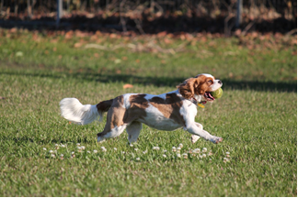

# SECTION 8 – Review of Plan and Annual Reporting

**Objective 1:** Comply with Section 68A (3) of the Act.

|  |  |  |
| --- | --- | --- |
| **Activity** | **When** | **Evaluation** |
| Provide the Department of Economic Development, Jobs, Transport and Resource Secretary with a copy of the Domestic Animal Management Plan and any amendments to the plan | November 2017 | Copy supplied and signed off |
| Review and report annually on the Domestic Animal Management plan and, if appropriate, amend the plan | Annually | Plan signed off by Council |

**Acronyms**

DAMP Domestic Animal Management Plan

BCC Banyule City Council

CSR Customer Service Request

VDDR Victorian Dangerous Dog Register

RSPCA Royal Society for Protection and Care of Animals

POCTA Prevention of Cruelty to Animals Act

MOU Memo of Understanding

MAV Municipal Association Victoria

AMSTAFF American Staffordshire Terrier

ABS Australian Bureau Statistics

RBD Restricted Breed Dog

DEDJTR Department of Economic Development, Jobs, Transport and Resource

AMO Animal Management Officer

# 

# Bibliography/References

2017 ABS Census Quickstats and Community Profile. [www.abs.gov.au/census](http://www.abs.gov.au/census)

20012-2016 Domestic Animal Management Plan