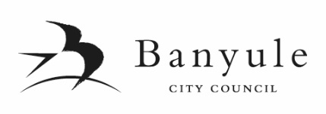

SUBMISSION FORM

PROPOSED BUDGET 2019/2020 and COUNCIL PLAN 2017-2021(YEAR 3)

I wish to make a submission to Banyule City Council regarding the proposed Budget and/or Council Plan presented to the Council meeting held on Monday 8 April 2019. My submission is in relation to:

Proposed Budget 2019/2020 and/or Proposed Council Plan 2017-2021(Year 3)

Comment: (please use block letters when completing this form)

I am making a submission as:

an individual a representative of an organisation or community group

I,
 | (Given Name) | (Surname)
of
 | (Address)
 | Organisation (if applicable)
Phone:
Email:
(if you provide your email address it will be assumed you agree to receive correspondence via email)

Do you wish to speak to this submission at the Council Meeting on Monday 20 May 2019?

Yes No (Note: only those that indicate their desire to speak will be given the opportunity to speak to their submission.)

The closing date for submissions is 5pm on Wednesday 8 May 2019. All submissions received by this date will be considered by the Council at the Ordinary Council Meeting on 20 May 2019.

Submissions need to be clearly marked ‘Council Plan Submission’ or ‘Budget Submission’.
Please send to: Banyule City Council, PO Box 94, GREENSBOROUGH VIC 3088
or email to: enquiries@banyule.vic.gov.au

Signed: Dated:

