5.3 Greensborough Parking Plan - Adoption

Author: Kathleen Petras - Transport Planning Team Leader, City Development
Ward: Bakewell

Previous Items
Council on 29 Apr 2019 7.00pm (Item 5.1 - Greensborough Parking Plan - Community Consultation)

EXECUTIVE SUMMARY
The Greensborough Parking Plan considers parking trends and growth projections in the Greensborough Activity Centre and surrounds and provides strategies to manage parking in the immediate and long term (20 years).
Community and stakeholder consultation was undertaken over 6 weeks from 29 April to 8 June 2019. Feedback was sought via a letter to 200 traders and 1500 surrounding residents, through Shaping Banyule, and via two community consultation sessions.
The community response obtained was minimal which possibly suggests that parking in Greensborough Activity Centre is not generally perceived as a matter of concern. Of the 20 attendees at the consultation sessions and seven submitters to Shaping Banyule there was general support for the draft Plan’s recommendations.
There was some uncertainty expressed regarding increases in parking enforcement but also acknowledgement that it is important to ensure people are parking as intended to allow access to others. There was also uncertainty expressed over the need to reduce car parking rates for new developments.
The background study undertaken in the development of the Greensborough Parking Plan found that the parking overlays current minimum car parking requirements over cater to the parking needs of the area and are excessive in comparison to similar metropolitan activity centres and may be a hindrance to future development opportunities.
Other areas of concern as raised by the Greensborough Chamber of Commerce along with traders and some residents was that; provision of new car parks is an immediate need, future development construction and long term impacts are underestimated, and that commuter parking issues are inadequately addressed.
The background study, that was conducted in September 2017 after there was full occupancy of the One Flintoff building, found that there is currently insufficient parking demand to justify the provision of new car parks.
A moderate increased need for car parking into the future is forecast. It is considered that this need can be comfortably met by the use of underutilised car parking along with an increase in the use of public and active transport modes.
The use of parking will continue to be monitored to ensure that the actual parking demand is in line with the forecast. The provision of new car parks will be given consideration if the demand does become excessive.
In regard to commuter parking, the State Government has made a commitment to increase the number of commuter parking spaces at Greensborough Station. Council manages parking restrictions in the vicinity of Stations to protect local trading and residents.

RECOMMENDATION
That Council:

- Adopt the Greensborough Parking Plan to guide the current and future management of car parking in and around the Greensborough Activity Centre.

- Continue to manage and adjust parking restrictions to ensure that they meet the needs of the users of the area.

- Advocate for the committed additional commuter parking to be provided at Watsonia, if it is unable to be accommodated as part of the new Greensborough Transport Interchange project.

- Review the car parking requirements within the Banyule Planning Scheme for the Greensborough Activity Centre to bring the parking rates in line with the state requirements and other major activity centres.

- Confirms its intention to consider a future development and public realm upgrade adjacent to Greensborough Walk by utilising level 5 of the multi-deck carpark and an additional multi-deck carpark to the south east of the existing structure to offset car parking, improve access and provide additional disability parking within Greensborough.

COUNCIL PLAN
This report is in line with Banyule’s Council Plan key direction to “Support sustainable transport”.
BACKGROUND
This report responds to item 5 of Council resolution C02019/57 to “consider a future report on the final Greensborough Parking Plan including community consultation obtained during the consultation period”.

The Banyule Integrated Transport Plan recommends the development of parking management plans for Banyule’s three Major Activity Centres. Greensborough is the third of these centres for which a parking plan has been developed following the adoption of parking plans for Heidelberg and Ivanhoe.

The study area for the draft Greensborough Parking Plan included a central commercial area (Zone A) and a surrounding residential area (Zone B) as shown in figure 1 below.

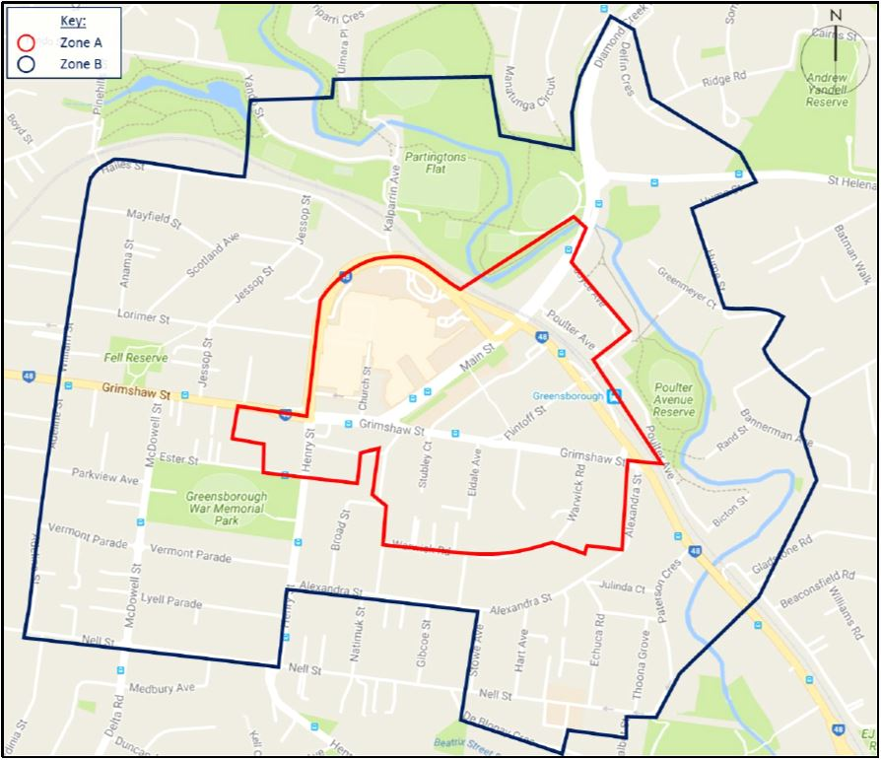

Figure 1: Study Area – Greensborough Parking Plan

Findings
The background study examined all publically available car parking including that which is privately owned (e.g. At Greensborough Plaza).
It was undertaken in September 2017 and found that the commercial centre contains a slight oversupply of car parking spaces. Currently at peak demand, 78% of publically available spaces are in use which leaves around 1000 spaces vacant. Parking supply is considered to be optimal when 85% of spaces are in use at peak demand.
It was also found that centrally some overstaying of parking time restrictions is occurring. The highest incidence was found occurring around Greensborough Plaza (18%).
In the surrounding residential zone there was found to be a large supply of parking that is currently significantly underutilised.
Increased future car parking demand was examined and found likely to be moderate due to the moderate commercial and residential growth expected in Greensborough. It was considered that increased use of underutilised parking spaces, both centrally and non-centrally located, along with increased use of public transport and walking and cycling to travel to the activity centre will be sufficient to meet the future demand over 20 years.

It was also forecast that parking needs for future residential dwellings will be largely accommodated within the surrounding residential areas where parking supply is currently abundant.

The study also examined the car parking requirements for new developments. It found that the current minimum car parking requirements over cater to the parking needs of the area, are excessive in comparison to similar metropolitan activity centres and may be a hindrance to future development opportunities.
Recommendations

The recommendations of the draft Greensborough Parking Plan were to:

- Maintain advocacy to State Government authorities to improve pedestrian, cyclist access and public transport service and facilities.
- Implement car park safety improvements to lighting, signage and access.
- Ensure sufficient parking opportunity for people with disabilities.
- Protect driveway access and increase parking enforcement where needed.
- Reduce car parking requirements for new developments.

CONSULTATION

Letters to invite participation in the community consultation were sent to over 1500 residents living within a 400m zone from the centre of the Greensborough Activity Centre and provided for 200 traders via the Greensborough Chamber of Commerce. Email notification was also provided to 20 stakeholders including local schools, churches and community groups.

The following response was obtained:
- 20 attendees at consultation sessions (Traders, RSL, All Saints Church and residents)
- 2 phone calls requesting hard copies of the draft Plan
- 7 submissions on Shaping Banyule
- 1 letter from the Greensborough Chamber of Commerce
- 6 letters of support for the Greensborough Chamber of Commerce letter from local businesses.

Considering the number of letters distributed to the community the response obtained was minimal suggesting that parking in Greensborough Activity Centre may not generally be perceived as a matter of concern.

Of those that did express interest the community was largely supportive of the draft recommendations. There was substantial support for the advocacy to the State Government to improve public and active transport modes to reduce the need for car use.

The community also supported the inclusion of adequate parking for people with disabilities along with supporting the improvement of car parking areas with better wayfinding, lighting, signage and access.

There was some uncertainty expressed regarding increases in parking enforcement but also acknowledgement that it is important to ensure people are parking as intended to allow access to others. There was also uncertainty expressed over the need to reduce car parking rates for new developments.

The main areas of concern as raised by the Greensborough Chamber of Commerce along with traders and some residents were that:

- Provision of new car parks is an immediate need and should be given higher priority.
- Future development construction and long term impacts are underestimated.
- There was inadequate addressing of commuter parking issues

A summary of community and stakeholder consultation undertaken in the development of the draft Greensborough Parking Plan is provided in Attachment 1.

The Greensborough Chamber of Commerce was provided with a direct response to their concerns by email after being unavailable for a meeting with Council representatives. The response is provided in Attachment 2.

DISCUSSION

The following discussion responds to the main concerns raised by the consultation.

The background study found that there is currently insufficient parking demand to justify the provision of new car parks. In the central area of Greensborough there is currently more parking provided than is optimal. These conditions were surveyed in September 2017 after there was full occupancy of the one Flintoff building.

In studying possible future demand, commercial and residential growth in Greensborough was taken in to consideration. It was found that development is expected to remain moderate. There is a foreseen increased need for car parking but it is considered that this need can be comfortably met by the use of currently underutilised car parking along with an increase in the use of public and active transport modes.

The use of parking will continue to be monitored to ensure that the actual parking demand is in line with the forecast. The adjustment of restrictions will occur to ensure that they meet the needs of the uses of the area. The provision of new car parks will be given consideration if the demand does become excessive.

Some alterations to existing carparks may be necessary to implement the planning framework of the Greensborough Principal Activity Centre Plan. One notable change is the potential for a future development and public realm upgrades adjacent to the Greensborough Walk, utilising level 5 of the multi-deck carpark. To enable this to occur an additional multi-deck carpark could be constructed to the south east of the existing structure to ensure parking is balanced. The new carpark would improve access to Flintoff Street and also allow for additional disability parking which are both actions of the parking plan.

Commuter parking at railway stations is managed by the State Government. Council has a role in advocating for the provision of commuter parking on behalf of its community. The State Government has made a commitment to increase the number of commuter parking spaces at Greensborough Station. This should be considered in the context of the best use of available land in the activity centre. Preference should be given to ensuring pedestrian and bus access to the station over car parking. If all or some of committed additional parking cannot be accommodated within the rail land in Greensborough, consideration should be given to providing it at other nearby stations within Banyule, such as Watsonia, which have direct access from the arterial road network and available land.

Council will continue to manage on-street parking restrictions in the vicinity of Greensborough Station to reduce the impact of commuter demand on local trading and residents.
LEGAL CONSIDERATION
There are no direct legal implications arising from the recommendation contained in this report.
HUMAN RIGHTS CHARTER
In developing this report to Council, the subject matter has been considered in accordance with the requirements of the Victorian Charter of Human Rights and Responsibilities.

It is considered that the subject matter does not raise any human rights issues.

OFFICER DECLARATION OF CONFLICT OF INTEREST
Section 80C of the Local Government Act 1989 (Act) requires members of Council staff, and persons engaged under contract to provide advice to Council, to disclose any direct or indirect interest in a matter to which the advice relates.

Council officers involved in the preparation of this report have no conflict of interest in this matter.
CONCLUSION
It is considered that the finalised Plan as provided as Attachment 3, should be adopted to manage parking in to the future in Greensborough. It has been developed using appropriate methodology and contains a set of effective recommendations to manage parking.

Community and stakeholder consultation has been thoroughly undertaken on the draft Greensborough Parking Plan. Concerns raised during the consultation have been appropriately addressed and general support has been obtained for the recommendations of the Plan.

ATTACHMENTS
No. | Title | Page
1 | Greensborough Parking Plan - Consultation Summary - August 2019
2 | Response to Greensborough Chamber of Commerce Concerns - August 2019
3 | Greensborough Parking Plan - July 2019

